**RESULTS AND DISCUSSIONS**

**User Interface Representation (of Respective Project)**

The user interface of the Potato and Tomato leaf disease detection system has been built using Streamlit, a lightweight Python library designed for creating interactive web apps for machine learning projects. The interface is simple and user-friendly, allowing users to upload an image of an apple leaf and receive a disease prediction instantly.

**Features of the System**

* Uses a custom CNN architecture for improved image classification.
* High accuracy (~81%) on validation data.
* Utilizes early stopping and checkpoint saving to prevent overfitting.
* Can be further deployed using a web interface for user interaction.

**Brief Description of Various Modules of the system**

**Image Upload:** Allows users to browse and upload an image of an Potato and Tomato leaf from their local system.

**Prediction Engine:** Accepts the image and runs it through the trained CNN model to classify it into one of the seven categories: ['Potato___Early_blight', 'Potato___Late_blight', 'Potato___healthy', 'Tomato___Bacterial_spot', 'Tomato___Early_blight', 'Tomato___Late_blight', 'Tomato___healthy']

**Result Display:** Displays the predicted disease along with the model confidence score.

Disease Information: Provides brief prevention and care tips based on the predicted disease.

**Warning Module:** If the uploaded image is not of an apple leaf or the model’s confidence is too low, the system provides an appropriate alert to the user.

**Snapshots of system with brief detail of each**

**Snapshot 1: Homepage of the Web Application**

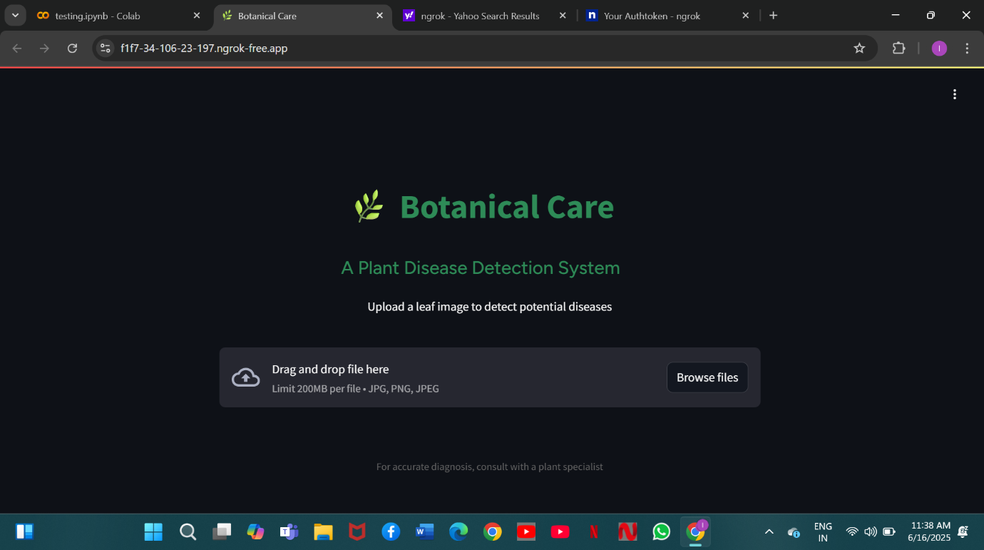

This is the homepage of the project: Botanical Care: A plant disease detection system which lets the user upload a JPG or PNG images of the leaf.

**Snapshot 2: Uploaded image preview**

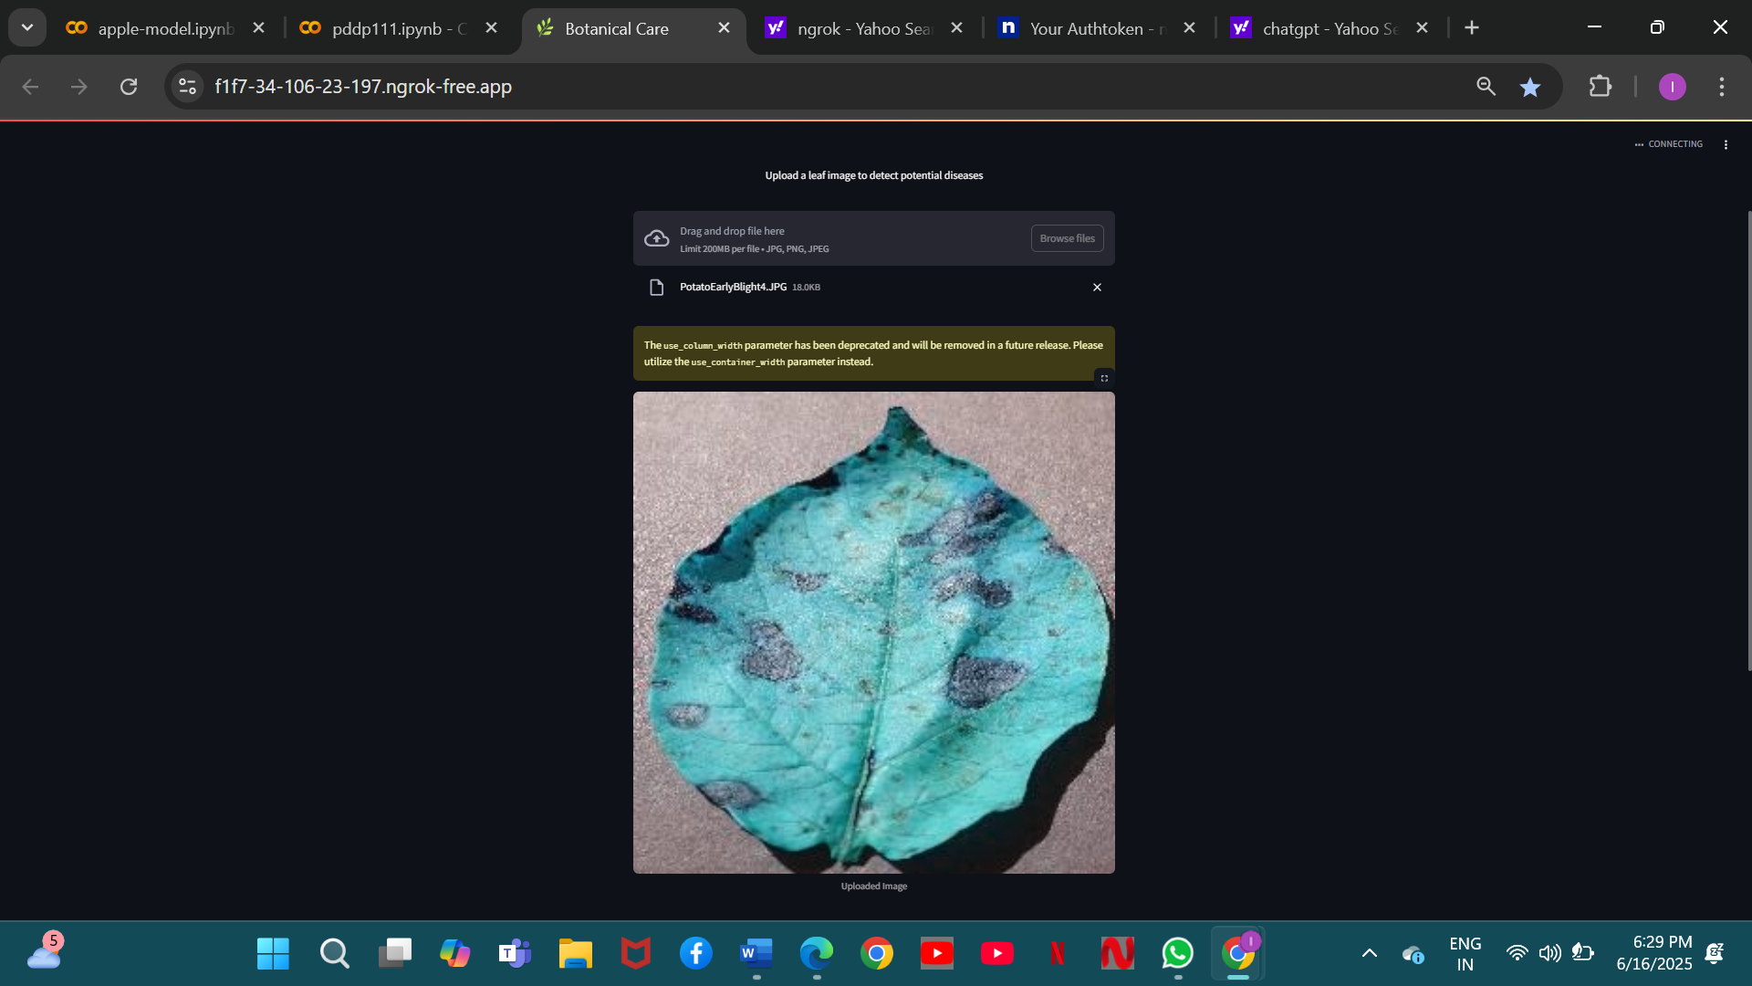

It shows the preview of the image uploaded by the user along with the size of the image and the image format.

**Snapshot 4: Prevention and Care Tips**

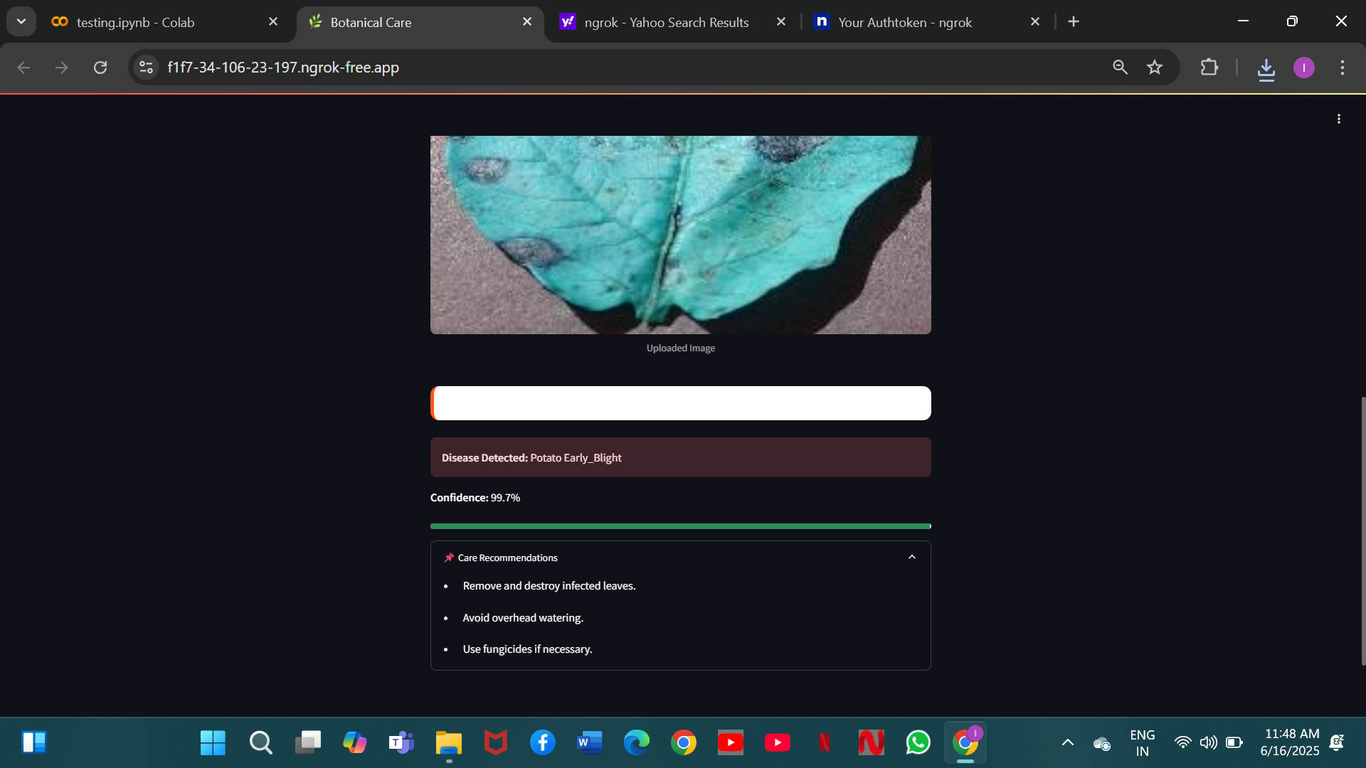

This shows the disease detected by the custom made CNN model along with the confidence which tells that how accurately it has predicted the disease of the uploaded image. It is also showing the care recommendations which can help the users to treat their infected plant.

**Snapshot 5: Model accuracy**

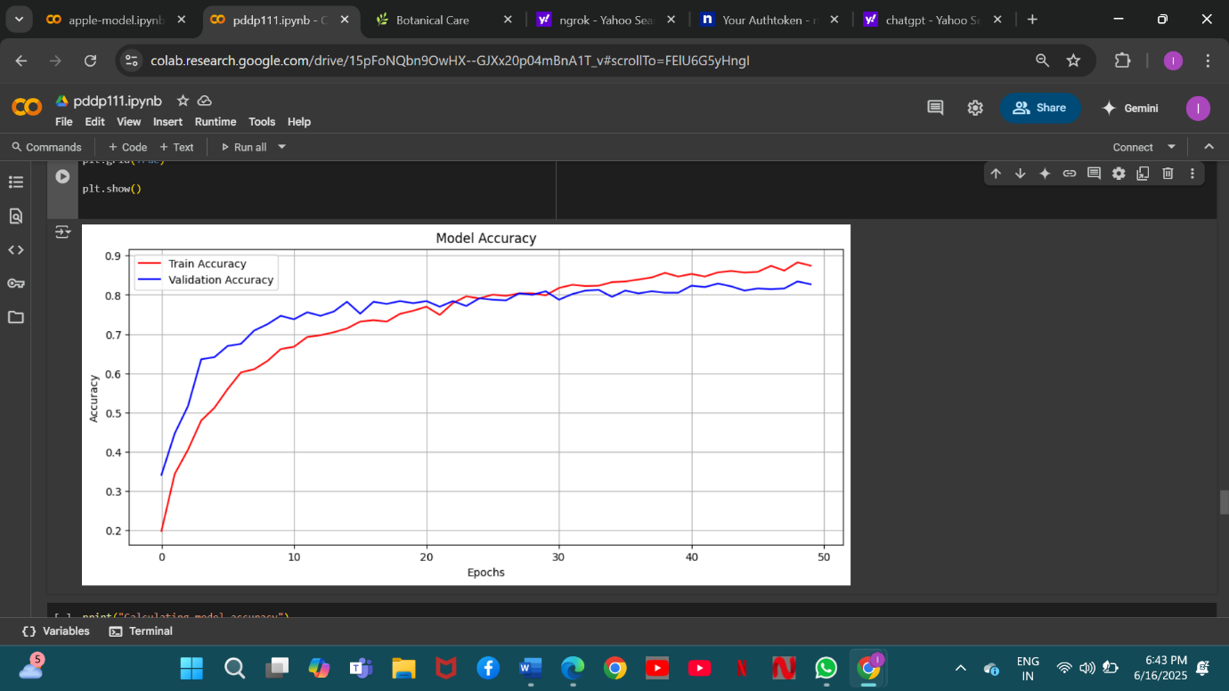

The above graph is showing the training and validation accuracy/loss across epochs. It demonstrates how well the model learned over time and whether overfitting/underfitting occurred.